Crop Disease Prediction
PROJECT SYNOPSIS
OF MINOR PROJECT

5th Semester

BACHELOR OF TECHNOLOGY
COMPUTER SCIENCE AND ENGINEERING (AI & ML)

SUBMITTED BY
Anurag Yadav - 301310922041
Anmol Kumar - 301310922020
Supriya Dhara- 301310922009
S. Nimmi- 301310922114

Session 2024-2025



RUNGTA COLLEGE OF ENGINEERING AND TECHNOLOGY BHILAI(C.G)

Rungta College of Engineering and Technology, Bhilai Department of CSE -Allied

Table of Contents

Chapter Title Page No.
- Introduction 01
- Rationale Behind the Study 02
- Objective 03
- Literature Review 04
- Feasibility Study 06
- Methodology/ Planning of work 07
- Flow Chart 08
- Expected Outcomes 09

Guide Name
Prof. Prabhjeet Kaur
CSE(AI/AIML)

Consent of Guide
Suggestions by the guide:

B. Tech Project Synopsis

Introduction:

The agricultural sector is increasingly challenged by crop diseases that pose a serious threat to food security and farmer livelihoods. These diseases can lead to significant yield losses, resulting in economic hardship for farmers and jeopardizing the stability of agricultural markets. Traditional methods of disease detection, which often rely on visual inspections and expert knowledge, are inherently limited; they can be time-consuming, subjective, and prone to error.
Recent advancements in deep learning technologies offer a transformative approach to crop disease prediction, enabling more efficient and accurate systems for early detection. By utilizing sophisticated algorithms and vast datasets, deep learning can analyse visual data and identify disease symptoms that may be missed by the human eye. This not only enhances the speed of diagnosis but also improves the overall reliability of disease management strategies.

Rationale Behind the Study:
The increasing frequency and severity of crop diseases pose a significant threat to global food security, farmer livelihoods, and the agricultural economy. As the world population continues to grow, the demand for food is rising, necessitating improvements in agricultural productivity and sustainability. Traditional methods of disease detection often fall short due to their reliance on manual inspections, which can be time-consuming, subjective, and prone to error. This situation calls for innovative solutions that leverage technology to enhance the efficiency and accuracy of crop disease management.
Key Reasons for Conducting the Study:
Need for Early Detection: Early identification of crop diseases is essential for effective management. The cost of inaction can be dire, resulting in not only decreased yields but also increased financial burdens on farmers. By implementing an AI-driven system for timely interventions, the potential for improving crop health and overall productivity becomes significantly higher.

Advancements in Deep Learning: The rapid advancements in deep learning technologies present an exciting opportunity for accurately detecting and diagnosing plant diseases through image analysis. With the ability to process vast amounts of visual data, deep learning algorithms can identify disease symptoms more effectively than traditional methods, promising higher accuracy and faster diagnoses.

Integration of Environmental Factors: Crop diseases are influenced by a variety of environmental conditions, including weather patterns, soil health, and moisture levels. This study aims to explore the synergetic potential of combining image data with real-time environmental inputs, enhancing predictive capabilities and offering a more holistic approach to disease management.

Objectives:
- Inadequate Information Dissemination:

Farmers may not have access to timely and accurate information regarding disease outbreaks, preventive measures, and effective treatments.

- Environmental Impact:

The indiscriminate use of pesticides to combat crop diseases can lead to adverse environmental effects and resistance among pathogens.

- Lack of Timely Diagnosis:

Traditional methods of diagnosing crop diseases often rely on the expertise of agronomists or extension workers, which may not be readily available, especially in rural areas.

Literature Review
S.No. | Author’s  Name | Title | Source | Y  ea  r | Methodology | Findings | Gaps
1. | Mohanty et al. | Using Deep Learning for Image-Based Plant Disease Detection | proceedings of the IEEE International Conference on Computer Vision (ICCV) | 2  0  1  6 | Developed a CNN model trained on over 50,000 images of diseased and healthy plant leaves. | Achieved high accuracy in identifying various plant diseases using CNNs. | Lacks integration of environmental data; focuses solely on image data.
2. | Ferentinos, K. P. | Deep Learning Models for Plant Disease Detection and Diagnosis | Applied Sciences | 2  0  1  8 | Reviewed multiple deep learning architectures and their performance on plant disease datasets. | Explored various deep learning models, highlighting their effectiveness in disease detection. | Limited focus on real-time applications and user accessibility.
3. | Huang, B., & Zhang, Y. | Deep Learning for Plant Disease Detection: A Review | Computers and Electronics in Agriculture | 2  0  1  8 | Analysed existing literature, summarizing methodologies and results from various studies. | Comprehensive review of deep learning techniques in plant disease detection. | Lack of detailed discussion on integrating environmental factors.
4. | Kouadio, A. A., et al. | Image Classification for Plant Disease Detection using Deep Learning | IEEE Access | 2  0  2  1 | Compared multiple CNN models using the PlantVillage dataset to evaluate their accuracies and efficiencies. | Established benchmarks for various CNN architectures in crop disease classification. | Insufficient exploration of hybrid models incorporating environmental data.
5. | Kaur, M., & Bhandari, S. | Web-Based Application for Plant Disease Detection using CNN | International Journal of Computer Applications | 2  0  2  2 | Created a CNN model integrated into a web application allowing farmers to upload images for diagnosis. | Developed a user-friendly web application for real-time disease detection. | Lacks integration of environmental data and feedback mechanisms.

Feasibility Study:

Technical Feasibility:
- Data collection:
The system will need access to high-quality datasets of crop images, along with environmental data such as temperature, humidity, and soil conditions. Partnerships with agricultural research organizations may be necessary to obtain diverse and comprehensive datasets.

Economic Feasibility:
- Cost Analysis:

Estimate the initial and ongoing costs associated with implementing the
project, including data acquisition, equipment, software, personnel, maintenance and operational expenses.

Environment Feasibility:
- Impact Assessment:
The system aims to enhance sustainable agricultural practices by reducing the need for chemical pesticides through early disease detection, leading to environmentally friendly farming.

Methodology/ Planning of work:

Data Collection Module
Sensors: Collect data on environmental conditions such as temperature, humidity, soil moisture, and light levels.
Remote Sensing: Uses drones, satellites, or aerial imagery to capture visual data of crop fields.
Field Surveys: Manual or semi-automated collection of data from field observations and sample testing.

Data Integration and Storage Module
Data Aggregation: Combines data from various sources, including sensors, remote sensing, historical records, and weather forecasts.
Data Storage: Manages and stores collected data in a structured format, typically in a cloud-based or local database.

Preprocessing Module
Data Cleaning: Removes noise and irrelevant information from raw data to improve quality.
Normalization: Standardizes data formats and scales for consistency.
Feature Extraction: Identifies and extracts relevant features from the data that are useful for analysis.

Disease Detection Module
Image Analysis: Uses computer vision techniques and machine learning algorithms to analyze images of crops for signs of disease.
Pattern Recognition: Identifies disease patterns and anomalies based on visual and sensor data.
Anomaly Detection: Detects deviations from normal patterns that may indicate the presence of diseases.

FLOW CHART:

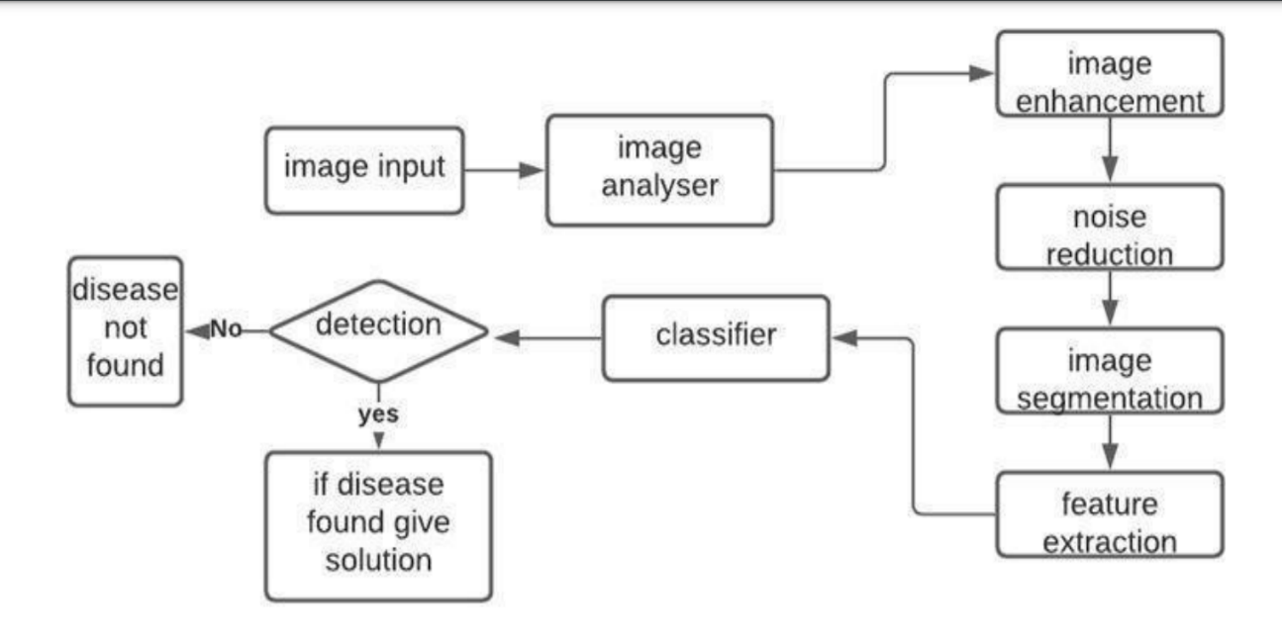

Expected outcomes:

- Accurate Disease Prediction
Development of a deep learning model capable of accurately identifying various crop diseases based on image analysis and real-time environmental data, leading to timely and effective interventions.

    - Enhanced Agricultural Productivity

Increased crop yields and reduced losses through early detection of diseases,
enabling farmers to take preventive measures before outbreaks escalate.

    - Increased Farmer Empowerment
Empowerment of farmers through access to advanced technology and information, enabling them to make informed decisions about crop management and treatment options.

